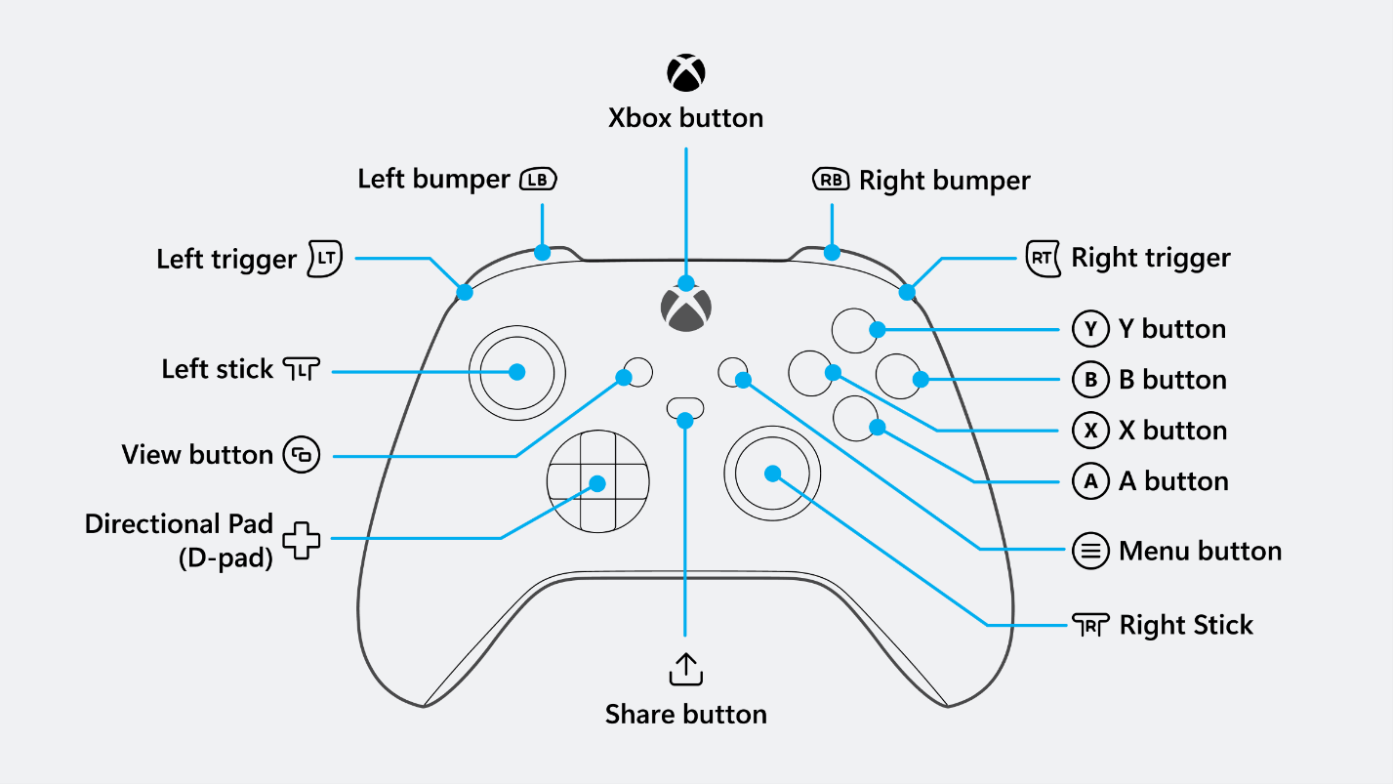

Left bumper - Elevator go down

Right bumper - Elevator go up

View - zero heading

B - coral out

A - coral in

Y – Elevator Home Position

X – Arm Flip

A – Coral Out

B – Coral In

Algae in

Algae out

Left/Right – Dpad

L4 – Y

L3 – X

L2 – B

L1 - A